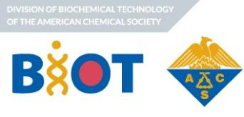
Candidates for 2026 ACS BIOT Officers
Position | Candidates
Chair-elect  (1 open position) | Venkatesh Natarajan
Treasurer  (1 open position) | Nick Vecchiarello  Caryn Heldt  Krunal Mehta
Councilor  (1 open position) | David Roush
Alternate Councilor  (3 open positions) | Evan Wells
Alternate Councilor  (3 open positions) | Stefano Menegatti
Alternate Councilor  (3 open positions) | Brian Paul
Alternate Councilor  (3 open positions) | Maryam Raeeszadeh Sarmazdeh

Division Chair-Elect
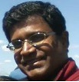
Venkatesh Natarajan, PhD.
Engineering Associate Director, Amgen
Venkatesh Natarajan’s association with BIOT began in his graduate school days. As a doctoral candidate in Prof Steven Cramer’s Research Group, he was a regular attendee and presenter. He continued this association in his professional career as an Applications and Process Engineer in the biotechnology industry. Over the last fifteen years, he has served as a Session Chair and as an Area Coordinator at several BIOT meetings. In 2020, he was the Program Co-Chair, along with Prof Mark Blenner, for what turned out to be the first-ever virtual BIOT meeting. Most recently (2021-2025), he served as Treasurer.
Venkatesh’s areas of focus have been developing and optimizing downstream processes, assessing new technologies and overall process economics. He is currently an Engineering Associate Director at Amgen and is based in Cambridge, MA.
Candidate Statement: I am excited to be considered for Chair-Elect of BIOT, an organization that has been part of my journey since graduate school. Over the years, I’ve been fortunate to serve as Area Coordinator, Program Co-Chair and Treasurer and these roles have deepened my appreciation for the strength of this community. As Chair-Elect, I look forward to fostering stronger connections across academia and industry, while creating inclusive opportunities that empower the next generation of biotechnology professionals. Together, we can continue to champion the value and integrity of biotechnology on a global scale.

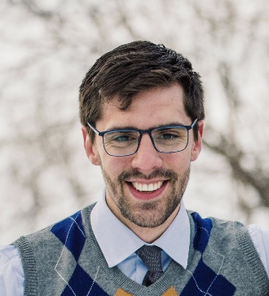
Division Treasurer
Nick Vecchiarello, PhD.
Assistant Professor, Department of Chemical Engineering, University of Virginia
Prof. Nick Vecchiarello is a faculty member in the Department of Chemical Engineering at the University of Virginia. He earned his Ph.D. from Rensselaer Polytechnic Institute with Steven Cramer and subsequently worked at Amgen as a late-stage process development scientist before returning to academia. Following Amgen, he completed his postdoctoral research in the MIT Chemistry Department, where he designed peptide conjugates for therapeutic applications. His research at UVA focuses on integrating high-throughput screening technologies with mechanistic and machine learning models to enable efficient downstream process development for biologics. His group also designs novel chromatographic surfaces to improve purification and polishing strategies for non-mAb therapeutics. Prof. Vecchiarello has served as Program Co-Chair of the PREP Symposium for the 2024 and 2025 meetings and as a Downstream Area Coordinator within ACS BIOT for the past three years. He recently received an NSF CAREER award to develop peptide-based mixed-mode adsorptive materials, advance mechanistic chromatography models, and lead a biomanufacturing summer workshop for undergraduate engineers.
Candidate Statement: I’m excited for the opportunity to serve as BIOT Treasurer and contribute to a community that has played an important role in my professional growth. In this role, I will focus on maintaining clear and transparent financial operations, ensuring timely reporting, and supporting the Executive Committee in responsible management of Division funds. I look forward to the prospect of being further involved in the BIOT community and supporting its mission of connecting industry and academia, fostering a strong scientific program, and sustaining an engaged and collaborative scientific community.

Division Treasurer
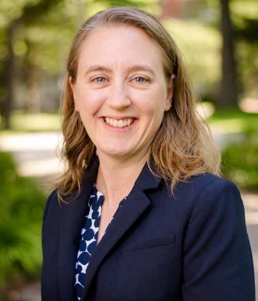
Caryn Heldt, PhD.
Professor, Department of Chemical Engineering, Michigan Technological University
Dr. Caryn L. Heldt is the Executive Director of the Health Research Institute, the James and Lorna Mack Chair in Continuous Processing, and Professor in the Department of Chemical Engineering at Michigan Technological University. She received her B.S. in Chemistry and Chemical Engineering from Michigan Technological University and her Ph.D. in Chemical Engineering from North Carolina State University. She has published over 50 peer-reviewed articles. In 2015, Dr. Heldt was awarded an NSF CAREER award to study virus surface chemistry. She was awarded the Bhakta Rath Research award at Michigan Tech in 2021 and the Faculty Distinguished Service award in 2022. Her lab is focused on the purification, inactivation and stability of viruses and gene therapy vectors.
Candidate Statement: I am excited to run for the position of Treasurer for the ACS BIOT Division. Having been an active member for many years, I deeply understand the division's strategic goals and its critical need for stable, transparent financial stewardship to support our community.

I have consistently served as a Session Chair and Area Coordinator, contributing directly to the quality of BIOT programming. This led to serving as the BIOT Program Co-Chair in 2021, which gave me a comprehensive view of the financial nuances of BIOT. Currently, as Membership Chair, I am acutely aware of the need for a direct relationship between BIOT and its members.

Furthermore, I have served as the volunteer Treasurer for three separate local organizations, managing budgets, ensuring compliance, and delivering clear financial reporting. I am eager to translate my BIOT knowledge and financial experience into providing reliable leadership for BIOT. I ask for your vote to serve the BIOT community as Treasurer.

Division Treasurer
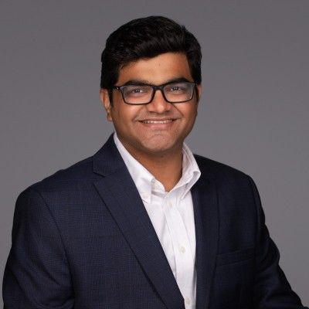
Krunal Mehta, Ph.D.
Head Of Downstream Biologics Drug Substance Commercialization, Merck & Co. Inc.
Dr. Krunal Mehta is an experienced leader in the field of bioprocessing, currently serving as Director and Head of Downstream Biologics Drug Substance Commercialization at Merck & Co. Inc. He holds a Ph.D. in Chemical and Biological Engineering from Rensselaer Polytechnic Institute. He earned his bachelor’s degree in chemical technology from Institute of Chemical Technology, Mumbai.
At Merck, Dr. Mehta has held several high-impact leadership roles, including leading a team of scientists and engineers across multiple sites, overseeing process characterization, technical transfer, process validation, and BLA authoring for late-stage biologics assets. Dr. Mehta has played a pivotal in the commercialization of two biologics over the past two years, including the successful launch of a first-in-class treatment for pulmonary arterial hypertension (PAH) and timely launch of a preventive pediatric mAb (against RSV), both assets anticipated to have significant revenue implications for the company.
Dr. Mehta began his involvement with ACS-BIOT as a graduate student, winning the William H. Peterson award for the best student poster presentation. He later served as a Session Chair and organized the networking session for ACS-BIOT (2016 – 2020). He has also served as Awards Co-Chair since 2017, overseeing several key awards for students and young professionals in bioprocessing and a student travel subsidy program. Dr. Mehta has progressed through various leadership roles including session chair at multiple ACS BIOT events, Area Coordinator, and now serves as industrial program chair for the 2026 ACS-BIOT. Dr. Mehta’s remarkable journey of increasing leadership within ACS-BIOT highlights his dedication and service for advancing the ACS BIOT community.
Candidate statement: As part of the executive committee for over 7 years, I have developed a deep understanding of our division’s operational needs, strategic goals, and financial oversight. Serving as the industrial program chair has provided me with valuable insights into program-related expenses, budget planning, and the process of securing sponsorships. These experiences have not only deepened my understanding of financial stewardship within ACS-BIOT but also prepared me to take on the responsibilities of Division Treasurer more effectively in the future. I am committed to leveraging these skills to ensure responsible management of our financial resources and maintain transparency to further support our community’s mission and growth. I respectfully seek your support for my candidacy as Division Treasurer. Thank you for your consideration and trust in my candidacy.

Councilor
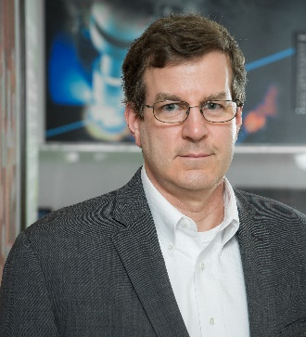
David Roush, Ph.D.
CEO/Distinguished Scientist, Roush BioPharma Panacea, LLC
Dr. David Roush is currently CEO/Distinguished Scientist at Roush BioPharma Panacea, LLC (RBP). RBP is an enterprise that provides scientific and technical guidance/consulting on all aspects of process development (ex. Developability, Control Strategy, Adventitious Agent Control, Modeling), technology development and commercialization enabled via a collaborative business model. Prior to founding RBP, David was a Distinguished Scientist in BioProcess R&D at Merck & Co., Inc. with more than 30 years of experience in bioprocess development (proteins, natural products and vaccines) directly contributing to the development of five life-saving therapeutics including the natural product/semi-synthetic anti-fungal drug Candidas™ and the immuno-oncology antibody Keytruda™. Specific examples include the development of both non-chromatographic and chromatographic purification processes for isolation and purification of an intermediate of Candidas™ which included an in situ solvent recovery step. Dr. Roush’s contributions to the development and commercialization of Keytruda™ were honored with the ACS BIOT Industrial Biotechnology Award (2016) and ACS Heroes of Chemistry Award (2021).
Dr. Roush has been actively engaged in advancement of scientific knowledge and the development of new technologies via collaborations with leading academic researchers and consortia (ex. NIIMBL, WuXi, Penn State, RPI, NC State) authoring more than 120 publications and presentations on the topics of primary recovery, adventitious agent control strategy and associated mechanisms, modeling and new technologies for hcp/lipase control. He received his Bachelor of Science degree in Chemical Engineering from Rice University and his PhD in Chemical Engineering from the University of Houston, under the guidance of Dr. Richard Willson. Dr. Roush’s doctoral research “Thermodynamic and Electrostatic Phenomena in the Ion Exchange of Proteins” was the synthesis of experimental and computational electrostatics and thermodynamics to explore protein-surface interactions, including the effects of charge variants and waters of hydration on chromatographic retention.
He has been an advocate for biotechnology community for more than 25 years, most recently serving as a BIOT Councilor representing the division at ACS Council and serving on the Meeting and Expositions Committee. David specifically contributed to the development of the strategic elements for the Future of Meetings (FOM) initiative, collaborating with ACS Sr. Leadership including M&E Chair, DAC Chair and the Chief Operating Officer of ACS.
Dr. Roush has supported the advancement of ACS BIOT via volunteering to serve in many leadership roles (Treasurer, Secretary, Division Chair), mentoring BIOT members and leading a BIOT Strategic Planning Retreat. He served as BIOT Industrial Programming Chair in 2009 and 2010 and as a Session Chair/Area Coordinator (15 times). David received the James M. Van Lanen Distinguished Service Award for his service to the ACS Division.
He currently serves as a member of the PREP Scientific Advisory Committee, Organizing Committee for Recovery of Biological Products Modeling Workshops, Secretary/Treasurer of Recovery of Biological Products Conference Series, and as an Adjunct Professor at University of Delaware Department of Chemical and Biomolecular Engineering, David also served on the Northwestern University Master of Biotechnology Program Industrial Advisory Board for a decade, providing feedback on curriculum and mentoring graduate students.

Alternate Councilor
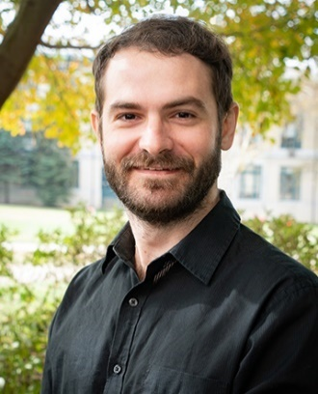
Evan Wells, Ph.D.
Manager, Upstream End to End Development, Johnson & Johnson
Evan Wells is a Manager at Johnson & Johnson where he has worked since 2021. He works in the Upstream End-to-End Development group where he leads early phase CMC programs from early development through clinical manufacturing and supports technology development initiatives. He manages a team of upstream leads who work mostly on other early phase programs, and he provides guidance, mentorship, and support as development progresses. Evan received his Ph.D. in Chemical Engineering from Carnegie Mellon University in 2020 under the supervision of Prof. Anne Robinson, where he studied the role of post-translational modifications on biopharmaceuticals and proteins involved in neurodegenerative disease. He resides outside of Philadelphia with his wife and cat and enjoys hiking, puzzles, gardening, and cooking fresh, flavorful meals.
Candidate Statement: Evan Wells is interested in the alternate councilor role to develop further connections within BIOT and across broader ACS. After a two-year term on the BIOT Executive Committee as technology coordinator (webmaster), he will focus his councillorship on mentoring the communications committee and supporting their community building and outreach efforts. Evan is also interested in supporting intra-BIOT initiatives on membership as well as growing a connection between BIOT and broader ACS efforts on communications and membership.

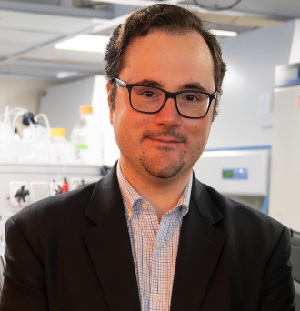
Alternate Councilor
Stefano Menegatti, Ph.D.
Associate Professor and Faculty Scholar, Dept of Chemical and Biomolecular Engineering
North Carolina State University, Raleigh, NC

Dr. Stefano Menegatti is an Associate Professor and Faculty Scholar in the Department of Chemical and Biomolecular Engineering at NC State University. He is the co-founder of the North Carolina Viral Vector Initiative in Research and Learning (NC-VVIRAL) and the Chief Technology Officer of LigaTrap Technologies, a company commercializing affinity adsorbents for bioseparations. Dr. Menegatti's main interests are in purification processes and analytical technologies dedicated to biological therapeutics. His group introduced the paradigm of "flow-through affinity chromatography" as well as several affinity ligands for the purification of proteins, viral vectors, and cells - totaling 27 patents and 120 peer-reviewed publications. His efforts on innovating biomanufacturing technologies have received several awards including the NSF CAREER award, the ALCOA Foundation Research Achievement Award, and the 2025 ACS BIOT Young Investigator Award.
Candidate Statement: I am excited to announce my candidacy for Alternate Councilor at ACS BIOT! My passion for biochemistry and biotechnology has shaped my career, and I believe in the power of collaboration to drive innovation and progress in our field. I will advocate for initiatives that promote the broad dissemination of cutting-edge research and professional development opportunities, ensuring that every member feels valued and empowered to contribute to our collective goals. Together, we can channel our talents and perspectives towards advancing knowledge and education in biochemistry and biotechnology. I welcome the opportunity to serve you and dedicate my work to inspire future generations of scientists. Thank you for your support!

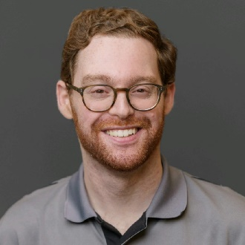
Alternate Councilor
Brian Paul, Ph.D.
Scientist, Global Biologics Manufacturing Science and Technology, Gilead Science
Brian Paul is a Scientist in Global Biologics Manufacturing Science and Technology at Gilead Sciences. He recently completed his PhD in Chemical and Biomolecular Engineering at the University of Delaware and the NIST Center for Neutron Research, where he studied the effects of hydrostatic pressure on protein stability and formulation behavior. He volunteered extensively with the Mid-Atlantic Graduate Student Chapter of ACS BIOT, serving two-year terms as Recruiting & Communications Lead and Chapter President. Brian looks forward to continuing his service to BIOT as an early-career professional
Candidate Statement: I am grateful for the opportunity to seek the role of Alternate Councilor within the ACS BIOT Executive Committee. Having recently transitioned from the university and national lab environment to the biotechnology industry, I bring a valuable perspective to support BIOT’s mission of connecting academia, industry, and government. During four years of service with the Mid-Atlantic Graduate Student Chapter of ACS BIOT, I served as Recruiting Lead and Chapter President and worked to build new connections between BIOT members at all career stages, including supporting the launch of a student-industry mentorship program. This program provides students with valuable career guidance while enabling industry mentors to support the next generation of talent. As an Alternate Councilor, I would be a strong advocate for BIOT’s role in supporting members at every stage of their careers, and I look forward to active involvement in BIOT through the Executive Committee and ACS initiatives.

Alternate Councilor
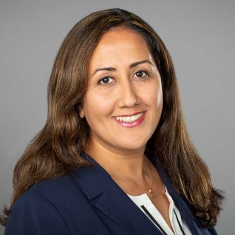
Maryam Raeeszadeh Sarmazdeh, Ph.D.
Associate Professor of Chemical Engineering, University of Nevada, Reno
Maryam Raeeszadeh Sarmazdeh Maryam Raeeszadeh-Sarmazdeh is an Associate Professor in the Department of Chemical and Materials Engineering. She served as the Graduate Program Director for Chemical Engineering at the University of Nevada, Reno (UNR) for three years. Since joining UNR in 2019, she has established the Biomolecular Engineering research program, which focuses on protein engineering and synthetic biology to develop novel therapeutics, drug delivery systems, and sustainability tools. She has secured several federal research fundings from the National Institutes of Health (NIH - NIGMS, NICHD, NIA), the National Science Foundation (NSF), and DOE awards. She is the recipient of the NSF CAREER Award and the NIH Maximizing Investigators’ Research Award (MIRA). She has also served as an early career editorial board member for the Journal of Biological Chemistry (JBC) and as Chair of Women in Chemical Engineering at AIChE.
Candidate Statement: ACS BIOT division became my go-to conference and professional home. I learned tremendously from the BIOT community, which has played a central role in my scientific and professional growth. Over the years, I have been fortunate to serve the division in several capacities, most notably as an Area Coordinator in sequential years, 2021 and 2022, as a session chair on numerous occasions, and as a member of award committees. I am also serving as the organizer of BIOT-WCC in Spring 2026. I value the unique balance BIOT provides, bringing together leaders from both academia and industry who are shaping the future of biotechnology. I also recognize the challenges we face as a community, including decreased engagement from past members and the need to strengthen connections between industry and academia. For BIOT to continue thriving, we must highlight and expand the value of our community, while fostering connections across career stages and sectors. If given the opportunity to serve in a service role, I will work to strengthen BIOT’s role as an inclusive and impactful community, support initiatives that recruit and engage early-career scientists and develop strategies to re-engage past members. My goal is to give back to the division that has given me so much, and to help ensure that BIOT continues to be a vibrant professional home for future generations of scientists and engineers.

